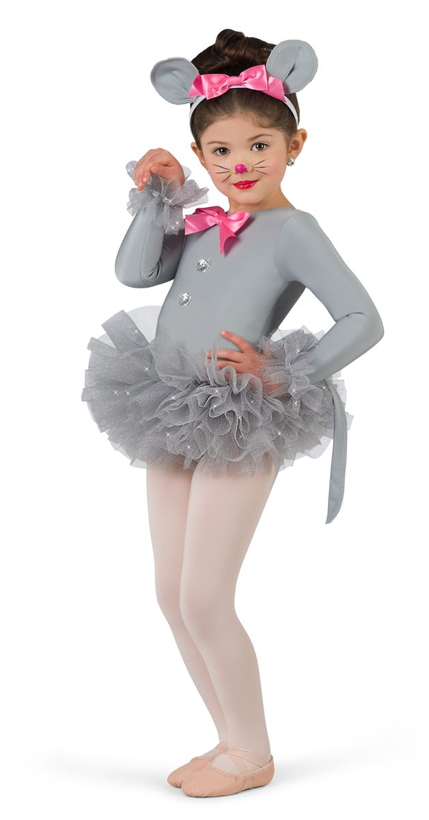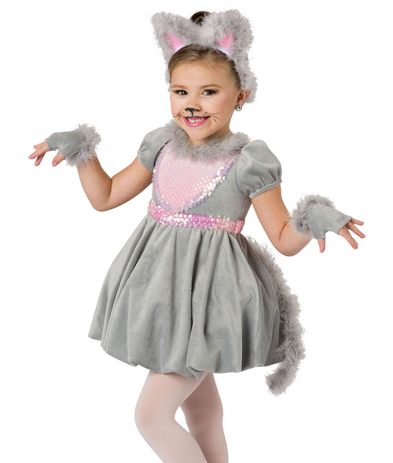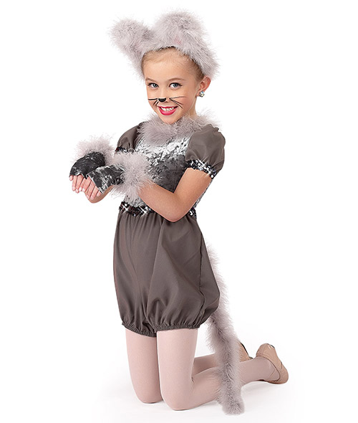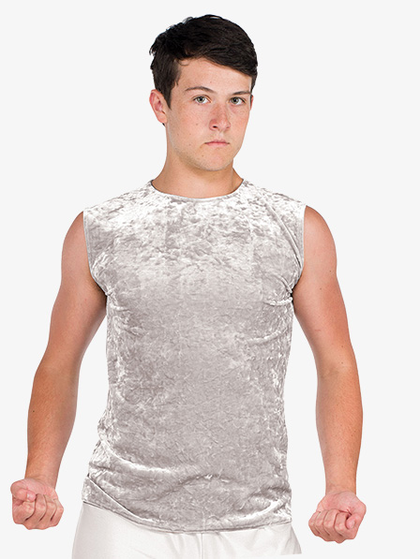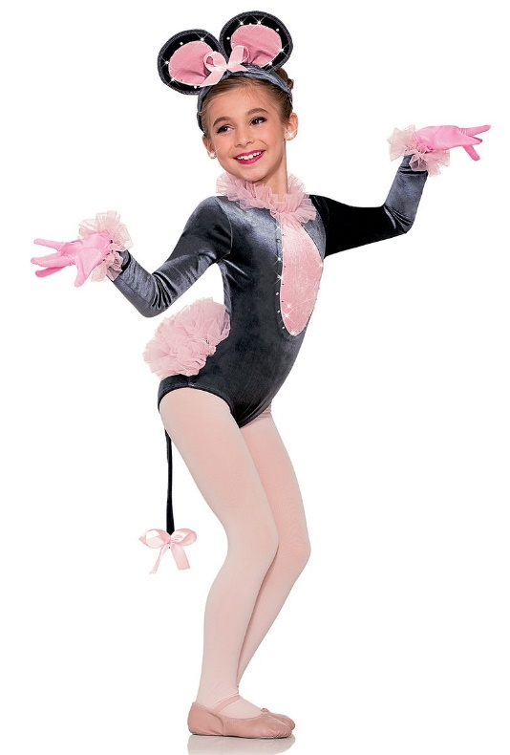

**Scene 2**

The Mice Fight

Proper tights must be worn especially with leo.

Students Name: ______________________

Students Size: ________________________

Tight Size and Color: ___________________

____________________________________

All Costumes are $55 plus $10 for tights

$60:_____________________________

If you find a similar costume please submit it to the instructor to confirm it will match the rest of the costumes.